## Macintosh HD:Users:ab55:Downloads:718wz4Y0P9L._SL1200_.jpgRobotics Posttest

Name:

Class:

1. Circle the definition of *robot workspace*,

underline definition of *degrees of freedom*

* **number of joints in the robot arm**
* **area the robot can reach**

1. Circle how many *degrees of freedom* the robot arm in the picture has:

**1 2 3 4 5 ­­­ 6**

1. Circle which is easier to pick up objects:

**Controlling the joints** (forward kinematics) **Controlling the hand** (inverse kinematics)

1. What did you learn today?

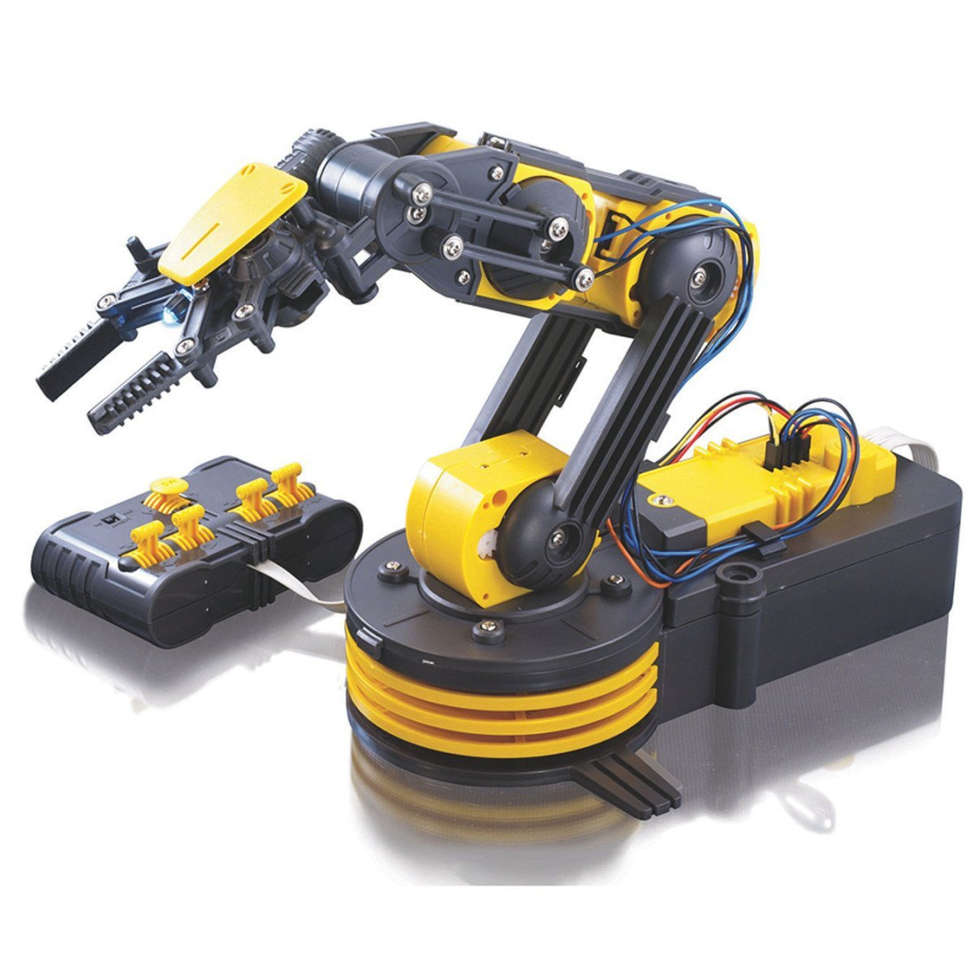

Name:

Class:

## Robotics Posttest

1. Circle the definition of *robot workspace*,

underline definition of *degrees of freedom*

* **number of joints in the robot arm**
* **area the robot can reach**

1. Circle how many *degrees of freedom* the robot arm in the picture has:

**1 2 3 4 5 ­­­ 6**

1. Circle which is easier to pick up objects:

**Controlling the joints** (forward kinematics) **Controlling the hand** (inverse kinematics)

1. What did you learn today?